Homework 2

Akash Choudhuri

# Problem 1:

The table for the first iteration is:

|  |  |  |  |  |
| --- | --- | --- | --- | --- |
| Point/ Cluster Center | C1 | C2 | C3 | Assignment |
| A1 | 8 | 7 | 3 | C3 |
| A2 | 7 | 2 | 8 | C2 |
| A3 | 8 | 7 | 1 | C3 |
| A4 | 6 | 3 | 3 | C2 |
| A5 | 10 | 5 | 7 | C2 |
| A6 | 2 | 7 | 5 | C1 |
| A7 | 7 | 2 | 6 | C2 |
| A8 | 3 | 6 | 10 | C1 |
| A9 | 5 | 4 | 2 | C3 |

New Centroids are:

C1= (5+2+3)/3,(1-1+1)/3 = (3.33,0.33)

C2= (-1+2-2+0+1)/5,(4+6+6+5+4)/5 = (0,5)

C3= (7+5+3+5)/4, (5+7+6+6)/4 = (5,6)

# Problem 2

MIN

|  |  |  |  |  |  |
| --- | --- | --- | --- | --- | --- |
| Points | A | B | C | D | E |
| A | 0 |  |  |  |  |
| B | 5.5 | 0 |  |  |  |
| C | 3.5 | 7.5 | 0 |  |  |
| D | 5.0 | 7.0 | 4.0 | 0 |  |
| E | 1.0 | 6.5 | 6.0 | 4.5 | 0 |

A,E is merged first

B= min(5.5,6.5)= 5.5

C= min(3.5,6.0)= 3.5

D= min(5.0,4.5)= 4.5

The Updated Table is

|  |  |  |  |  |
| --- | --- | --- | --- | --- |
| Points | A,E | B | C | D |
| A,E | 0 |  |  |  |
| B | 5.5 | 0 |  |  |
| C | 3.5 | 7.5 | 0 |  |
| D | 4.5 | 7.0 | 4.0 | 0 |

C is merged with (A,E)

B= min(5.5,7.5) = 5.5

D= min(4.5,4.0) = 4.0

The updated table is

|  |  |  |  |
| --- | --- | --- | --- |
| Points | A,E,C | B | D |
| A,E,C | 0 |  |  |
| B | 5.5 | 0 |  |
| D | 4.0 | 7.0 | 0 |

D is merged with (A,E,C)

Finally B is merged with (A,E,C,D).

The resultant Dendogram is:

MAX

|  |  |  |  |  |  |
| --- | --- | --- | --- | --- | --- |
| Points | A | B | C | D | E |
| A | 0 |  |  |  |  |
| B | 5.5 | 0 |  |  |  |
| C | 3.5 | 7.5 | 0 |  |  |
| D | 5.0 | 7.0 | 4.0 | 0 |  |
| E | 1.0 | 6.5 | 6.0 | 4.5 | 0 |

A,E is merged first

B= max(5.5,6.5)= 6.5

C= max(3.5,6.0)= 6.0

D= max(5.0,4.5)= 5.0

The Updated Table is

|  |  |  |  |  |
| --- | --- | --- | --- | --- |
| Points | A,E | B | C | D |
| A,E | 0 |  |  |  |
| B | 6.5 | 0 |  |  |
| C | 6.0 | 7.5 | 0 |  |
| D | 5.0 | 7.0 | 4.0 | 0 |

C is merged with D

B= max(7.5,7.0)=7.5

(A,E)= MAX(6.0,5.0)=6.0

The updated table is

|  |  |  |  |
| --- | --- | --- | --- |
| Points | A,E | C,D | B |
| A,E | 0 |  |  |
| C,D | 6.0 | 0 |  |
| B | 6.5 | 7.5 | 0 |

(A,E) is merged with (C,D).

Finally B is merged with (A,E,C,D).

The resultant dendogram is:

AVERAGE

|  |  |  |  |  |  |
| --- | --- | --- | --- | --- | --- |
| Points | A | B | C | D | E |
| A | 0 |  |  |  |  |
| B | 5.5 | 0 |  |  |  |
| C | 3.5 | 7.5 | 0 |  |  |
| D | 5.0 | 7.0 | 4.0 | 0 |  |
| E | 1.0 | 6.5 | 6.0 | 4.5 | 0 |

A,E is merged

B= AVG(5.5,6.5) = 6.0

C= AVG(3.5,6)= 4.75

D= AVG((5.0,4.5)=4.75

The Updated Table is

|  |  |  |  |  |
| --- | --- | --- | --- | --- |
| Points | A,E | B | C | D |
| A,E | 0 |  |  |  |
| B | 6.0 | 0 |  |  |
| C | 4.75 | 7.5 | 0 |  |
| D | 5.0 | 7.0 | 4.0 | 0 |

C,D is merged

B=AVG(7.5,7.0)=7.25

(A,E)= AVG(4.75,5.0)= 4.875

The updated table is

|  |  |  |  |
| --- | --- | --- | --- |
| Points | A,E | C,D | B |
| A,E | 0 |  |  |
| C,D | 4.875 | 0 |  |
| B | 6.0 | 7.25 | 0 |

(A,E) and (C,D) are merged.

B is merged with (A,E,C,D).

The resultant Dendogram is:

# Problem 3:

The transformation can simply be obtained by:

P=

=

=

So,

y11= 0.59

y12=2.88

y21=2

y22=3.38

# Problem 4

For the first part, we take the RHS of the required proof

1-g(z)

= 1-

=

=

=

= g(-z)

For the second part, we need to first show that the function is bijective (ie, one-to-one and onto).

To prove that the function is one-to-one, if we choose 2 numbers zand , we get

g( = and g( = , we can only have g(= g( if z , so the function is one-to-one.

To prove that the function is onto, we need to prove that the inverse exists, which is the original proof itself

Let x=g(z)=

or

Taking logarithm in both sides, we get

z= -ln(

or z=ln(

This corresponds to , which proves the statement.

# Problem 5

## Cho.txt

The ground Truth Cluster visualization after converting it to 2 dimensions using PCA looks like:

## K-Means

### Euclidean Distance

We initially used Euclidian Distance as a distance metric. The elbow plot plotting inertia with different values of k was:

K=4 was the optimal number of cluster number. No empty clusters were found. The generated plot is, as follows:

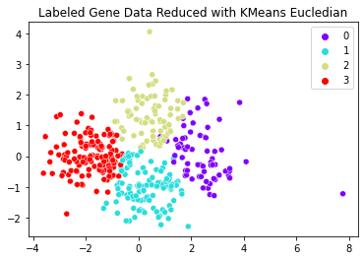

The plot for k=5 looks like:

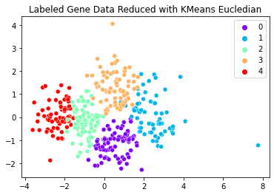

We can compare the ground truth with the output of K=5 here. The results are:

Rand index= ﻿0.799

Jaccard Coefficient= 0.239

For k=4,

Rand index= ﻿0.794

Jaccard Coefficient= 0.205

I did not find any empty clusters as cluster center initialization was one of the points. The method does not detect outliers but instead just assigns it to the nearby cluster. But the PCA plots of the ground truth clusters and K means for K=5 look very similar.

### Manhattan Distance

We initially used Euclidian Distance as a distance metric. The elbow plot plotting inertia with different values of k was:

K=4 was the optimal number of cluster number. No empty clusters were found. The generated plot is, as follows:

The plot for k=5 looks like:

We can compare the ground truth with the output of K=5 here. The results are:

Rand index= ﻿0.794

Jaccard Coefficient= 0.105

For k=4,

Rand index= ﻿0.797

Jaccard Coefficient= 0.047

I did not find any empty clusters as cluster center initialization was one of the points. The method does not detect outliers but instead just assigns it to the nearby cluster. But the PCA plots of the ground truth clusters and K means for K=5 look very similar but not as good as Euclidean.

## Hierarchical Agglomerative Clustering

### Method: Ward variance minimization algorithm, Distance: Euclidian

The Data in its original dimension is used to generate dendrograms to understand the optimal number of clusters. The dendrogram is, as follows:

We decide to find the number of clusters using the dendrogram by finding the largest horizontal space that doesn't have any vertical lines (the space with the longest vertical lines). This means that there's more separation between the clusters. We can draw a horizontal line that passes through that longest distance at 12.5. 5 seems a good indication of the number of clusters that have the most distance between them. Using this number, we assign clusters to data points. The result in 2D using PCA is given as follows:

We see that in the 2D space, out cluster assignments seem to be more pronounced and better than the ground truths. This means that we still need more features to effectively cluster the data in the way ground truth has done.

Rand index= ﻿0.758

Jaccard Coefficient= 0.170

The reason why Jaccard Coefficient is low is because the cluster numbers do not correspond to the actual numbers. So, the only way we can compare is by checking other performance metrics (shown later).

### Method: Complete, Distance: Minkowski

The Data in its original dimension is used to generate dendrograms to understand the optimal number of clusters. The dendrogram is, as follows:

We decide to find the number of clusters using the dendrogram by finding the largest horizontal space that doesn't have any vertical lines (the space with the longest vertical lines). This means that there's more separation between the clusters. We can draw a horizontal line that passes through that longest distance at 5.9. 5 seems a good indication of the number of clusters that have the most distance between them. Using this number, we assign clusters to data points. The result in 2D using PCA is given as follows:

Notice that Cluster 3 has only 1 point. It seems to be weird to use 1 whole cluster for just an outlier point. So, the cluster assignment is not a good as the previous method.

Rand index= ﻿0.785

Jaccard Coefficient= 0.130

|  |  |  |  |
| --- | --- | --- | --- |
| Model/Metric | Silhoutte Score | Calinski-Harabasz Index | Davies- Bouldin Index |
| Ground Truth | 0.086 | 71.39 | 1.97 |
| Ward | 0.161 | 106.77 | 1.54 |
| Complete | 0.224 | 100.69 | 1.22 |

So, by this, we can understand that the Ward Method does better than Complete compared to the true ground truth clusters. The problem of both the methods of HAC is that both of them are heavily biased towards globular clusters.

## Density Based

We choose the optimal value of the hyperparameters by taking the Minimum Silhoutte Score. The best value is given below and the candidate values are given in silscore.csv.

|  |  |
| --- | --- |
| Score | Parameters |
| -0.11902 | Eps: 0.7, min_sample: 4 |

With this value the clustering is:

Another way to choose the optimal eps would be to check the elbow plot. We keep the min_samples to its default value and the elbow plot thus generated is given as follows:

The elbow is seen at 2.5. Setting the eps at that value the resultant clustering plot is:

We can see that density based clustering does not do a good job as the clusters are not dense enough but has a more hierarchal relationship. Either way, the performance metrics are:

|  |  |  |  |
| --- | --- | --- | --- |
| Model/Metric | Silhoutte Score | Calinski-Harabasz Index | Davies- Bouldin Index |
| Ground Truth | 0.086 | 71.39 | 1.97 |
| DBSCAN | 0.446 | ﻿6.34 | 2.26 |

Rand index= ﻿0.238

Jaccard Coefficient= 0

## Gaussian Mixture Model

GMM is a generative model determining the optimal number of components for a given dataset. A generative model is inherently a probability distribution for the dataset, and so we can simply adjust the model likelihoods using some analytic criterion such as the [Akaike information criterion (AIC)](https://en.wikipedia.org/wiki/Akaike_information_criterion) or the [Bayesian information criterion (BIC)](https://en.wikipedia.org/wiki/Bayesian_information_criterion). This will help us in choosing the optimal number of n_components. The plots is:

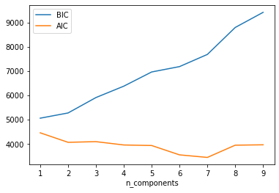

We see that is we have 7 components, AIC is minimized. The resultant Clusters are:

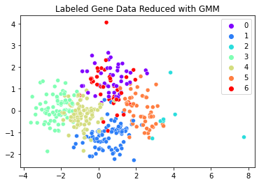

|  |  |  |  |
| --- | --- | --- | --- |
| Model/Metric | Silhoutte Score | Calinski-Harabasz Index | Davies- Bouldin Index |
| Ground Truth | 0.086 | 71.39 | 1.97 |
| GMM | 0.147 | ﻿86.06 | 1.66 |

As we can see the performance metrics values are very close to the ground truths.

If we set n_components=5, the plot is:

The other Performance metrics are:

Rand index= ﻿0.7814

Jaccard Coefficient= 0.058

For n_components=5,

Rand index= ﻿0.786

Jaccard Coefficient= 0.105

This algorithm does a good job and better than K-Means as clusters do intersect.

## Spectral Clustering

We choose the optimal cluster by ﻿identifying the maximum gap which corresponds to the number of clusters by eigengap heuristic. The plot is:

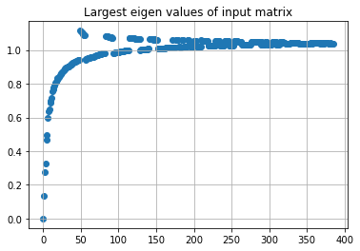

We see that is we have 6 clusters, maximum eigen gap is minimized. The resultant Clusters are:

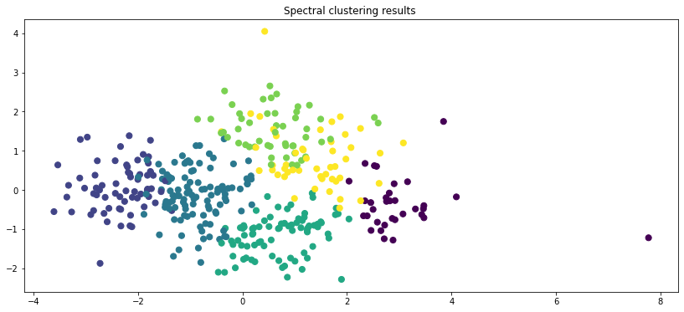

|  |  |  |  |
| --- | --- | --- | --- |
| Model/Metric | Silhoutte Score | Calinski-Harabasz Index | Davies- Bouldin Index |
| Ground Truth | 0.086 | 71.39 | 1.97 |
| SC | 0.189 | ﻿105.66 | 1.56 |

As we can see the performance metrics values are very close to the ground truths.

If we set number of clusters=5, the plot is:

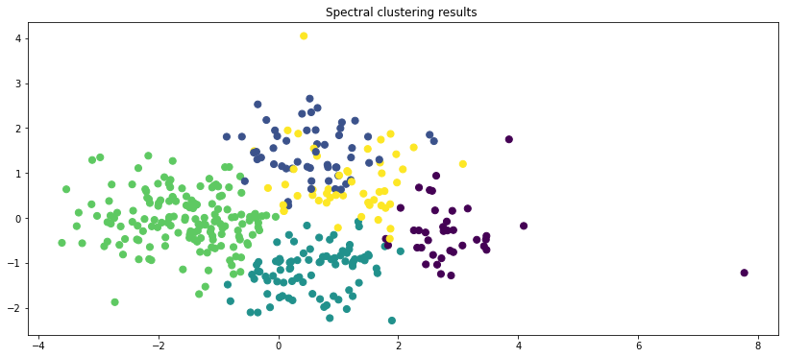

The other Performance metrics are:

Rand index= ﻿0.779

Jaccard Coefficient= 0.153

For n_components=5,

Rand index= ﻿0.799

Jaccard Coefficient= 0.112

This method performs really well as well. But not as good as GMM. It is not susceptible to outliers. But it might overfit to globular clusters.

## Iyer.txt

The ground Truth Cluster visualization after converting it to 2 dimensions using PCA looks like:

## K-Means

### Euclidean Distance

We initially used Euclidian Distance as a distance metric. The elbow plot plotting inertia with different values of k was:

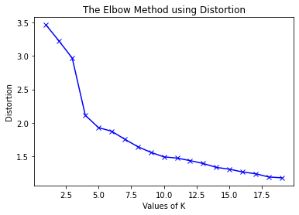

K=10 was the optimal number of cluster number. No empty clusters were found. The generated plot is, as follows:

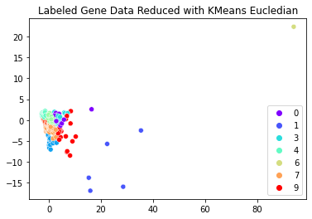

The plot for k=11 looks like:

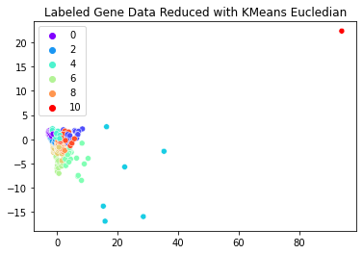

We can compare the ground truth with the output of K=11 here. The results are:

Rand index= ﻿0.8040

Jaccard Coefficient= 0.112

For k=10,

Rand index= ﻿0.777

Jaccard Coefficient= 0.032

I did not find any empty clusters as cluster center initialization was one of the points. The method does not detect outliers but instead just assigns it to the nearby cluster. But if the right number of clusters is given it does detect outliers. But the PCA plots of the ground truth clusters and K means for K=11 look very similar.

### Manhattan Distance

We initially used Euclidian Distance as a distance metric. The elbow plot plotting inertia with different values of k was:

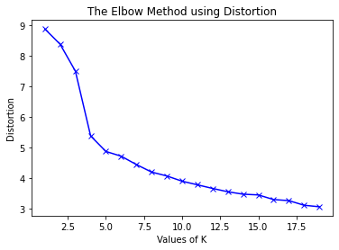

K=5 was the optimal number of cluster number. No empty clusters were found. The generated plot is, as follows:

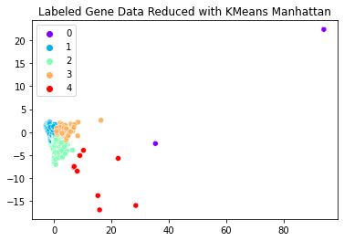

The plot for k=11 looks like:

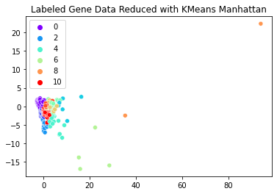

We can compare the ground truth with the output of K=11 here. The results are:

Rand index= ﻿0.708

Jaccard Coefficient= 0.098

For k=5,

Rand index= ﻿0.617

Jaccard Coefficient= 0.037

I did not find any empty clusters as cluster center initialization was one of the points. The method does not detect outliers but instead just assigns it to the nearby cluster. But if right number of clusters are given, it does detect outliers. But the PCA plots of the ground truth clusters and K means for K=11 look very similar but not as good as Euclidean.

## Hierarchical Agglomerative Clustering

### Method: Ward variance minimization algorithm, Distance: Euclidian

The Data in its original dimension is used to generate dendrograms to understand the optimal number of clusters. The dendrogram is, as follows:

We decide to find the number of clusters using the dendrogram by finding the largest horizontal space that doesn't have any vertical lines (the space with the longest vertical lines). This means that there's more separation between the clusters. We can draw a horizontal line that passes through that longest distance at 19. 11 seems a good indication of the number of clusters that have the most distance between them. Using this number, we assign clusters to data points. The result in 2D using PCA is given as follows:

Rand index= ﻿0.719

Jaccard Coefficient= 0.026

We see that in the 2D space, outlier points are present and needs to be taken care of, which this model does.

The reason why Jaccard Coefficient is low is because the cluster numbers do not correspond to the actual numbers. So, the only way we can compare is by checking other performance metrics (shown later).

### Method: Complete, Distance: Minkowski

The Data in its original dimension is used to generate dendrograms to understand the optimal number of clusters. The dendrogram is, as follows:

We decide to find the number of clusters using the dendrogram by finding the largest horizontal space that doesn't have any vertical lines (the space with the longest vertical lines). This means that there's more separation between the clusters. We can draw a horizontal line that passes through that longest distance at 10.

The resultant clusters in 2D are given by:

Rand index= ﻿0.515

Jaccard Coefficient= 0.0067

Thus, it is easily understood that both the above methods of HAC are less susceptible to outliers. But they are more biased towards globular clusters.

|  |  |  |  |
| --- | --- | --- | --- |
| Model/Metric | Silhoutte Score | Calinski-Harabasz Index | Davies- Bouldin Index |
| Ground Truth | -0.033 | 20.23 | 2.39 |
| Ward | 0.161 | 387.64 | 0.98 |
| Complete | 0.513 | 325.90 | 0.62 |

We can see that none of the above methods perform anywhere close as the ground truths. Thus, some features may be missing and may be required to do effective clustering corresponding to the ground truths.

## Density Based

We choose the optimal value of the hyperparameters by taking the Minimum Silhoutte Score. The best value is given below and the candidate values are given in silscore1.csv.

|  |  |
| --- | --- |
| Score | Parameters |
| 0.3713 | Eps: 0.7, min_sample: 4 |

With this value the clustering is:

Another way to choose the optimal eps would be to check the elbow plot. We keep the min_samples to its default value and the elbow plot thus generated is given as follows:

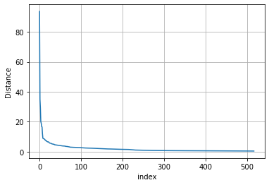

The elbow seems to have happened at 10, so we choose that value and the resultant cluster is, as follows:

This looks like a better cluster. The performance metrics are, as follows:

|  |  |  |  |
| --- | --- | --- | --- |
| Model/Metric | Silhoutte Score | Calinski-Harabasz Index | Davies- Bouldin Index |
| Ground Truth | 0.086 | 71.39 | 1.97 |
| DBSCAN | 0.88 | ﻿306.46 | 0.83 |

Rand index= ﻿0.172

Jaccard Coefficient= 0

Density based clustering does not do well as most points are clustered together and no fine graining can be done.

## Gaussian Mixture Model

GMM is a generative model determining the optimal number of components for a given dataset. A generative model is inherently a probability distribution for the dataset, and so we can simply adjust the model likelihoods using some analytic criterion such as the [Akaike information criterion (AIC)](https://en.wikipedia.org/wiki/Akaike_information_criterion) or the [Bayesian information criterion (BIC)](https://en.wikipedia.org/wiki/Bayesian_information_criterion). This will help us in choosing the optimal number of n_components. The plots is:

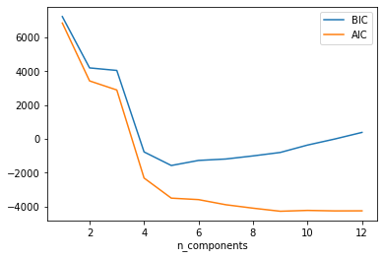

We see that is we have 9 components, AIC is minimized. The resultant Clusters are:

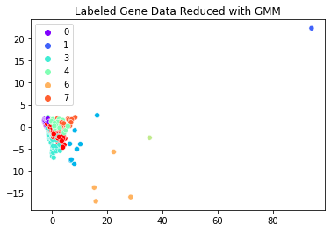

|  |  |  |  |
| --- | --- | --- | --- |
| Model/Metric | Silhoutte Score | Calinski-Harabasz Index | Davies- Bouldin Index |
| Ground Truth | 0.086 | 71.39 | 1.97 |
| GMM | 0.414 | ﻿398.45 | 1.01 |

As we can see the performance metrics values are very close to the ground truths.

If we set n_components=11, the plot is:

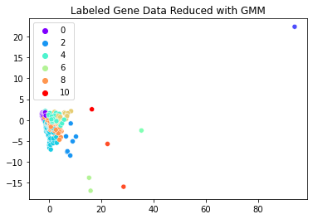

The other Performance metrics are:

Rand index= ﻿0.7613

Jaccard Coefficient= 0.102

For n_components=9,

Rand index= ﻿0.7613

Jaccard Coefficient= 0.102

This algorithm does a good job and detects outliers as well as intersecting clusters.

## Spectral Clustering

We choose the optimal cluster by ﻿identifying the maximum gap which corresponds to the number of clusters by eigengap heuristic. The plot is:

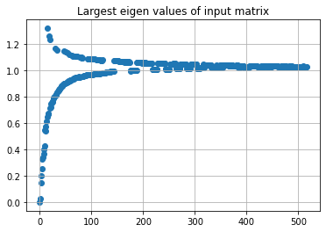

We see that is we have 14 clusters, maximum eigen gap is minimized. The resultant Clusters are:

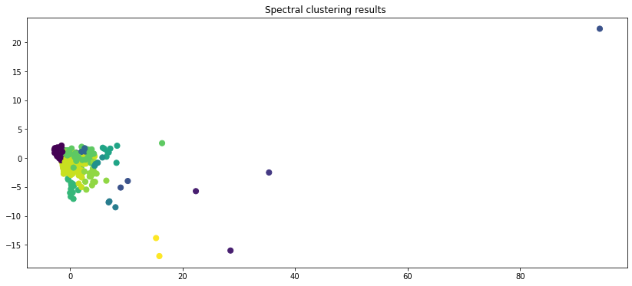

|  |  |  |  |
| --- | --- | --- | --- |
| Model/Metric | Silhoutte Score | Calinski-Harabasz Index | Davies- Bouldin Index |
| Ground Truth | 0.086 | 71.39 | 1.97 |
| SC | 0.470 | ﻿61.78 | 1.57 |

As we can see the performance metrics values are very close to the ground truths.

If we set number of clusters=5, the plot is:

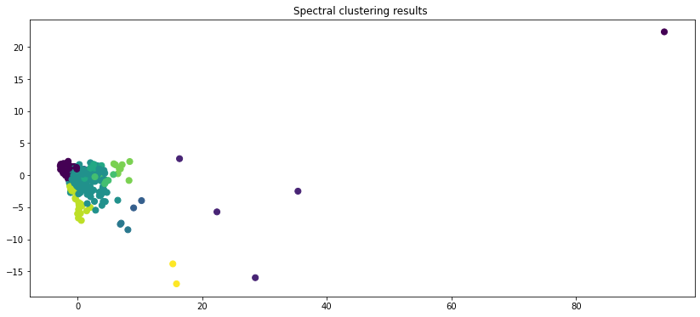

The other Performance metrics are:

Rand index= ﻿0.717

Jaccard Coefficient= 0.011

For n_components=5,

Rand index= ﻿0.676

Jaccard Coefficient= 0.002

This method performs not very well as the graph is not fully connected. It is not susceptible to outliers. But it might overfit to globular clusters.

The final Ranking Table is, as follows:

|  |  |  |
| --- | --- | --- |
| Rank | Cho.txt | Iyer.txt |
| 1 | K Means (Euclidian) | K-Means (Euclidean) |
| 2 | Gaussian Mixture Model | Heirarchal (Ward) |
| 3 | Heirarchal (Ward) | Gaussian Mixture Model |
| 4 | Spectral Clustering | Spectral Clustering |
| 5 | DBSCAN | DBSCAN |
| Outlier | No | Yes |

Final Points:

* Distance Metric matters in K-Means. Here Eucledian did best.
* GMM and HAC perform pretty well if the data has some inherent hidden relationship.
* Density based models do not perform well if there are hidden relationship other than density.
* In HAC, Wards Algo significantly outperformed the simpler method.